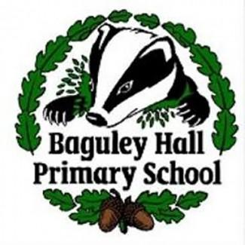
Behaviour Policy
2022-2023

Contents:

Page 1: Inspiring positive behaviour and deterring unacceptable behaviour – The 6 Principles of Nurture
Page 2: UNICEF Gold Rights Respecting and Peace Mala School
Page 3 - 4: British Values and REACH
Page 5: Responding to unacceptable behaviour
Page 6: Using the restorative practice approach
Page 7-8: Additional response to unacceptable behaviour in KS2
Page 9: Responding to serious unacceptable behaviour
Page 10: Appendices

This policy should be read in conjunction with the Anti-Bullying Policy, E - Safety Policy and the Restricted Items Policy.
At Baguley Hall Primary School, we believe that positive behaviours are extremely important to a successful education. We work to create a learning environment where everyone feels valued, secure and motivated to learn. We firmly believe that every member of our school community has a responsibility to teach children socially acceptable behaviour that considers the rights of everyone and develops responsible citizens.
We inspire positive behaviour and deter unacceptable behaviour by following the Six Principles of Nurture:

Staff help children to understand the rules, expectations and boundaries. Learning is challenging and appropriate for children’s individual needs. We celebrate individual achievements in our Worker of the Week award. We make reasonable adjustments to support children with additional needs and/or disabilities.

Staff have high expectations of behaviour. Staff model positive behaviour. Staff preserve children’s dignity when addressing unacceptable behaviour. Every classroom has a ‘safe base’ area with Zones of Regulation resource. Every class creates their own class charter about how staff and children will respect the UNCRC. Every class has their own behaviour management system which allows for a fresh start every day (see appendix 1 examples).
Staff value the link between home and school, working in partnership with parents and carers. Every classroom has a visual timetable. Staff prepare children for big and small changes whenever possible. Staff use non-verbal signals consistently across every classroom.

Children’s learning is understood developmentally

The classroom offers a safe base

The importance of transition in children’s lives

THE SIX PRINCIPLES OF NURTURE

The importance of nurture for the development of wellbeing

All behaviour is communication

Staff separate unacceptable behaviour from the child. Staff try to understand and resolve the reason behind the behaviour. Staff give children a chance to correct unacceptable behaviour before putting a sanction in place.

Language is a vital means of communication

Staff seek to build strong positive relationships with every child they work with. Staff use every chance to praise positive behaviour. Children with consistently positive behaviour are given responsibility roles in school. Staff wait for 100% attention before addressing the class to allow them to speak instead of shout. Class behaviour rewards are relationships/experience based.

Staff teach children the language they need to express themselves and learn. When a child is not ready to communicate verbally, staff give them alternative ways to communicate (e.g. using Zones of Regulation resource, visual aids, writing). Staff use 100% participation strategies during lessons.

We respect all of the UN Rights of the Child. They help us to understand why positive behaviour is so important:
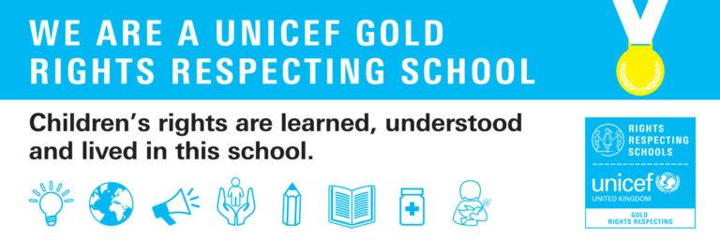

Article 12: Children have the right to give their opinions freely on issues that affect them. Adults should listen and take children seriously.
Article 13: Children have the right to share freely with others what they learn, think and feel, by talking, drawing, writing or in any other way unless it harms other people.
Article 15: Children can join or set up groups or organisations, and they can meet with others, as long as this does not harm other people.
Article 28: Every child has the right to an education…discipline in schools should respect children’s rights and never use violence.
Article 29: Children’s education should help them fully develop their personalities, talents and abilities. It should teach them to understand their own rights, and to respect other people’s rights, cultures and differences. It should help them to live peacefully and protect the environment.
Article 30: Children have the right to use their own language, culture and religion - even if these are not shared by most people in the country where they live.
Article 39: Children have the right to get help if they have been hurt, neglected, treated badly or affected by war, so they can get back their health and dignity.

Our Golden Rule:
Treat others as you would wish them to treat you.

Learning and following our British Values help us to understand why positive behaviour is an important part of life in modern Britain:

Mutual respect: Everyone deserves to be respected equally.
Individual liberty: We encourage and support children to explore and feel proud of who they are and what is important to them. We learn about how we are responsible for our choices and actions.
The rule of law: Rules help us to take care of each other and to make sure everyone is treated fairly.
Tolerance of different faiths and beliefs: We celebrate and value being an inclusive and diverse school.
Democracy: We plan opportunities for everyone in our school community to have their say about different issues.

We all aim to develop our REACH characteristics. They help us to focus on learning, showing and celebrating positive behaviour.
Empathy
Resilience
Aspiration
Confidence
Honesty
EYFS, KS1, LKS2 and UKS2 have worked hard on exploring what each REACH characteristic means to them. Please see the next page to see all of their fantastic ideas.
Empathy
Resilience
Aspiration
Confidence
Honesty
 | EYFS | KS1 | LKS2 | UKS2
Resilience | - You try your best  - You know it’s ok to make a mistake | - You are able to ask for help  - You ‘Bounce back’ when something you don’t enjoy happens | - You understand and manage your feelings  - You don’t give up. You keep trying - even when things are tricky  - You are open to ask for help when you need it  - You have the ability to ‘bounce back’ when things upset you | - You hold yourself accountable. Resilient people don't blame others or outside forces for their problems.  - You are self-aware  - You can manage strong emotions and impulses  - You are mentally strong and have will power  - You do not give up ‘at the first hurdle’  - You persevere
Empathy | - You are kind  - You are a good friend | - You care about how other people feel  - You treat others how you would like to be treated | - You take an interest in others  - You understand that others experience the same feelings as you do | - You give others space to feel their emotions and help them when they are ready to talk  - You show compassion and kindness to others  - You actively listen to others when it is their turn to talk
Aspiration | - You always try your best  - You believe you can do it | - You aim high  - You learn from your mistakes and do things better next time | - You understand what you need to do to improve  - You have big dreams for the future  - You want to be the best that you can be | - You have high expectations of yourself and believe that you can reach your goals  - You focus on your goals and how you will achieve them – putting in 100% effort to achieve your aspirations  - You know your strengths and weaknesses – you know which areas that you need to improve  - You are inspired by good role models – in school, in the community and perhaps by famous people.
Confidence | - You are proud to do things well  - You can share what you think with others | - You believe in yourself  - You always join in  - You always have a go | - You challenge yourself to be the best that you can be  - You are kind and help others to feel good about themselves  - You have a growth mindset – rather than saying ‘I can’t do that’ you say ‘I can’t do that yet’ etc | - You practise self-care and look after yourself mentally and physically  - You build good friendships and relationships with others  - You know what is a negative friendship or relationship and how this can ‘drain your confidence battery’
Honesty | - You always tell the truth | - You always try to do the right thing  - You tell others how you feel and what you think | - You tell the truth even when it is difficult  - You can admit when you are wrong  - You tell the truth (to others and to yourself) | - You do not cheat  - You are honest about your strengths and weaknesses  - You may make mistakes but you try hard to make thing better again  - Your honesty make you reliable and trustworthy

How we respond to unacceptable behaviours

Expected behaviours | Unacceptable behaviours
- Respecting others  - Respecting the school environment  - Engaging in learning  - Safe behaviour | - Disrespecting others  - Disrespecting the school environment  - Disrupting learning  - Dangerous behaviour

Staff respond to unacceptable behaviour in a confident, calm, consistent, fair and proportionate manner. The aim of any response to unacceptable behaviour is to maintain the culture of the school, restore a calm and safe environment in which all pupils can learn and thrive, and prevent the recurrence of misbehaviour.
Step 1 - The present staff member will use a range of de-escalation and distraction strategies (see appendix 2 for examples).

if unacceptable behaviour continues

Step 2 - The present staff member will privately remind the child that a sanction will be put in place if the unacceptable behaviour continues. Wherever possible, this sanction will be a logical consequence linking to the unacceptable behaviour (e.g. making up lost learning time, loss of privileges, tidying classroom, etc).

if unacceptable behaviour continues
Step 3 - The present staff member will put the sanction in place.

if unacceptable behaviour continues
Step 4 – The present staff member will refer to a member of the Senior Leadership Team.

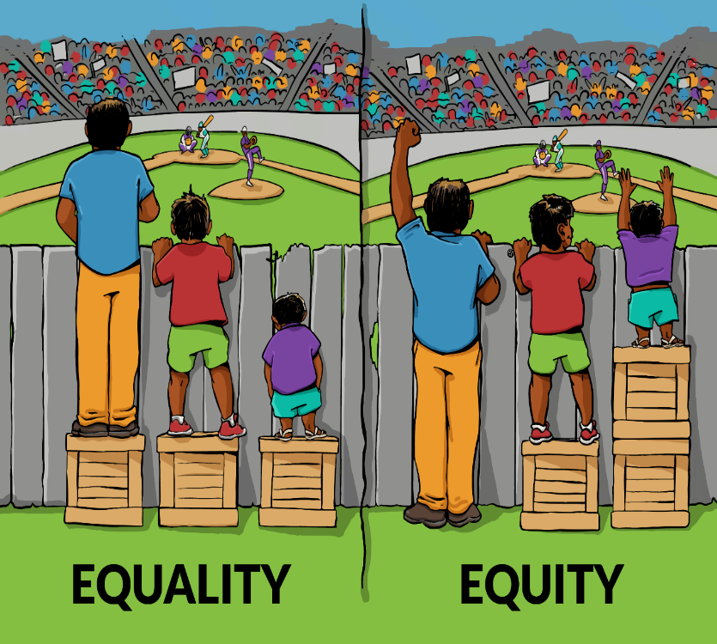

We will always take into account the specific circumstances and requirements of each individual child when supporting and responding to them.
We will create personalised behaviour plans for children in need of additional support to meet the behaviour expectations of our school.
Remember: ‘fair’ is not giving everyone the same, it is giving everyone what they need.

Using restorative practice after an incident of unacceptable behaviour

Following an incident of unacceptable behaviour, staff will follow three steps of dialogue with children. This will take place when the situation has de-escalated and those involved are ready to engage in discussion. This will be delivered in a way that is appropriate to the individual child’s age and understanding. Visual aids and other communication tools can be used to support this to take place.

- Reflect
  - What was the problem?
  - What went wrong?
  - How did you feel before/during the incident?
  - How do you feel now?
  - What were you thinking before/during the incident?
  - What are you thinking now?
  - Who else was affected?
  - How did it make them feel?
  - Why was it unacceptable?

- Resolve
  - What could you do to solve the problem if it happens again?
  - Which other people can help you?
  - How could they help you?
  - How can we make sure this doesn’t happen again?
  - What do you need to do instead the next time you feel that way?
  - What can help you to make a positive choice in the future?

- Restore
  - What can you do to make things right?
  - What can you do to make other people involved feel better?
  - What would you want to happen next if this had happened to you?

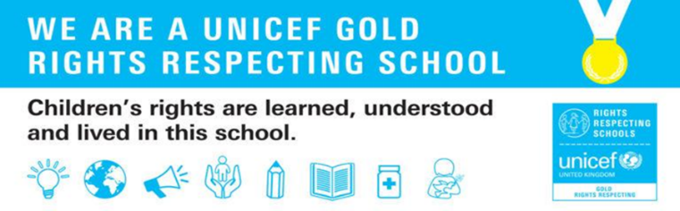
KS2 Class behaviour book record for unacceptable behaviour
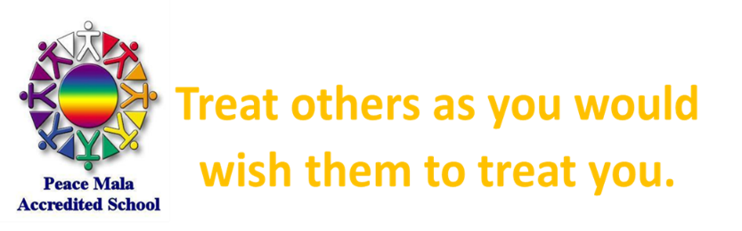

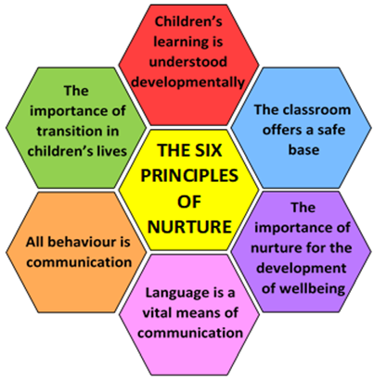
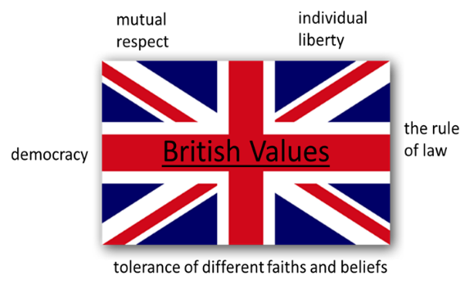
Article 12 Every child has the right for their voice to be heard.
Article 29 Every child has the right to an education that helps them to reach their full potential.

What will happen if there is unacceptable behaviour?
1. Reminder that if unacceptable behaviour continues, their name will go in the book
2. Their name is written in the book.
3. If child’s name is in the book 5+ times by Friday
⇒ Teacher will talk with parents on Friday (see next page for detail of meeting structure)
⇒ Phase leader will meet with child the following Monday
4. If this repeats the following week:
⇒ Teacher will talk with parents
⇒ The Headteacher or Deputy Headteacher will meet with child
5. If this repeats for a third week:
⇒ The child and their grown ups will need to have a meeting in school.
Baguley Hall Child View Class : ________
Which unacceptable behaviours in our class...
• Do not respect other children’s right to learn or right to rest and play?
• Do not make our classroom a safe base?
• Do not follow the golden rule?
• Do not follow our British values?
KS2 behaviour meeting structure (for classteachers and parents/carers)
1. Discuss what happened before
- Had reminder that if unacceptable behaviour continued, their name would go in the book
- Their name was written in the book.
- As child’s name was in the book 5+ times by today
- Teacher required to talk with parents/carers today
- Phase leader will meet with child next week on Monday

2. Discuss what is happening now
- Reflect
  - Why has the child’s name been in the book?
  - Does the child remember any triggers?
  - Why is this unacceptable behaviour? Refer to our school values.
  - Who else has this affected?

- Resolve
  - How can we make sure this doesn’t happen again?
  - What do you need to do instead the next time the trigger happens?
  - What/who can help you to make a positive choice in the future?

- Restore
  - What can you do to make things right?
  - What can you do to make the other people involved feel better?

3. Discuss what will happen next
Phase leader will meet with the child on Monday
If the child continues to show persistent unacceptable behaviour next week after the phase leader meeting
If the child shows expected behaviour next week after the phase leader meeting

- Phase leader will talk with parents/carers
- Phase leader will meet with the child and they will start a daily report card.
- At the end of the week the child will review their report card with their teacher
The child is ready for a fresh start.
How we respond to serious unacceptable behaviours
Child can stay on report card if they find it helpful
If the child shows expected behaviour by the end of the week
Review meeting with Headteacher or Deputy Headteacher for next steps decision.
Child can start an individualised plan
Child can come off report, no further provision
If the child continues to show persistent unacceptable behaviour

Senior Leadership Team staff involvement and parent/carer contact will be initiated immediately in cases of serious unacceptable behaviour. At this stage, a decision will be made about what disciplinary action will follow and how appropriate support will be provided to all parties involved.

Whilst we do everything we can to promote and ensure a safe and mutually respectful environment for all our pupils and staff, there are situations when the behaviour of one individual, or group of individuals, might have a detrimental impact on the health and wellbeing of another. If another child is a victim in an incident of serious unacceptable behaviour, any measures that they feel would support them will be carefully considered (also see restorative approach on next page). All adults involved with them at home and school will be made aware of the incident and should check in on their welfare in the following days. Parents/carers will be encouraged to feedback about any ongoing anxieties or concerns following the incident.

Due to the safety of children being of the highest importance in our school, if serious unacceptable behaviour could lead to a child committing an offence, injuring themselves, or others, or damaging property, Team Teach strategies for safe holding may be used. This would only be used when completely necessary as an absolute last resort.

Staff will keep a record of any incidents of serious unacceptable behaviours on CPOMS.

Serious unacceptable intentional behaviours
- Serious physical aggression  - Use of object/weapons to hurt others  - Bringing restricted items to school (see restricted items policy)  - Racism  - Biphobic, transphobic or homophobic incidents  - Sexual behaviour  - Inappropriate incidents/abuse using technology  - Exploitation | - Bullying (S.T.O.P. – several times on purpose):  - verbal  - physical  - online  - social  - discriminatory

Appendix 1
Examples of behaviour managements systems and rewards

- Group/team points
- Time to play a game/carry out an activity
- Time to create
- Time to spend with a chosen peer/adult
- Additional playground time
- Access to special resources to use together
- Visit to chosen staff member/peer to share an achievement
- Classroom
- Table points
- Class dojo
- Raffle tickets
- Stickers
- Marble jar
- Secret student

Appendix 2
Examples of distraction and de-escalation strategies

- Timer/countdown
- Change of face
- Direct to simple task (e.g. sharpen pencil/deliver a message)
- Praise nearby child for positive behaviour
- Movement break
- Change of environment
- Remind/reassure that help is available
- Verbal/visual reminder of what is needed now and what the next step is
- Acknowledge and validate feelings
- Zones of regulation visual aid
- Visual prompt of expected/unacceptable behaviours
- Deep breathing exercise
- Minimise verbal interaction
- Time to talk with staff member
- Direct to structured calm down time in safe base/another area with a task to do on return (e.g. ‘I can see you need some time out, that’s ok. When you come back, please ..[e.g. collect the books/give out pencils etc])
- Reminder of previous positive action/achievement (e.g. “It was great when you….yesterday, let’s help you get back to that”
- Use of clear, direct language in simple instructions (e.g. “we/you will…”, “it is time to…” instead of asking)
- Rephrase disrespectful language (e.g. “did you mean…”)
- Break down activity into smaller steps

