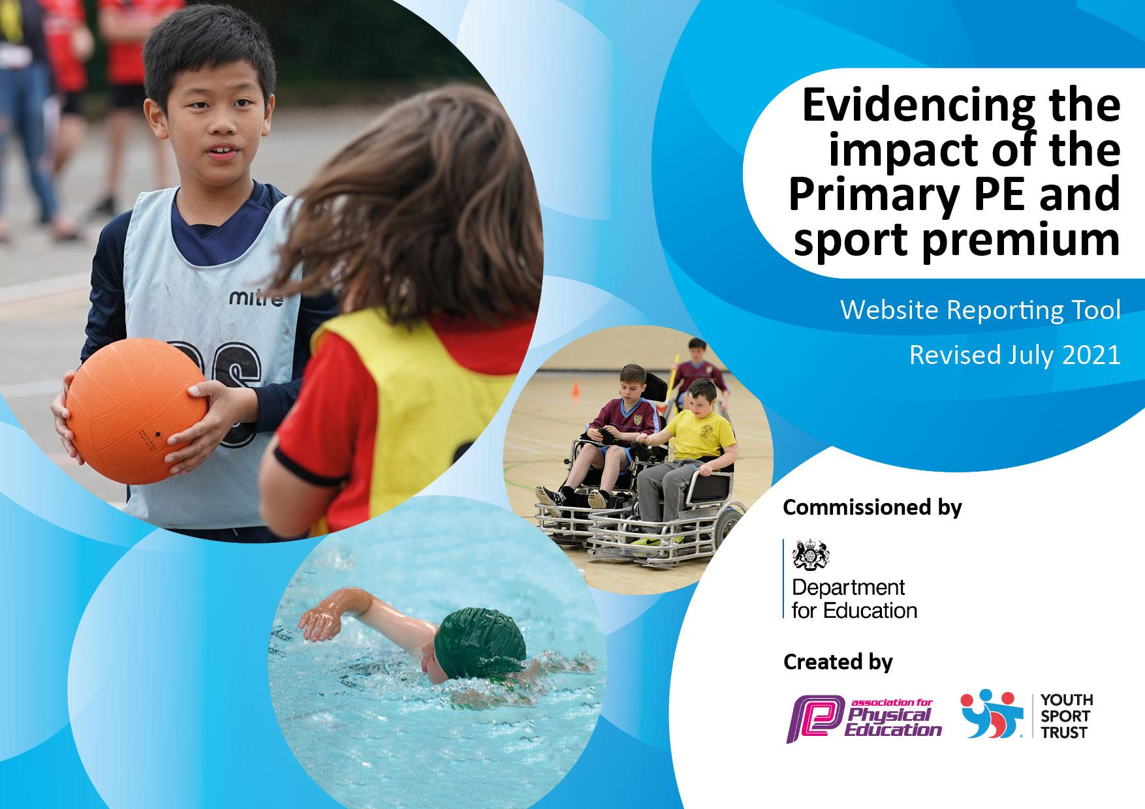
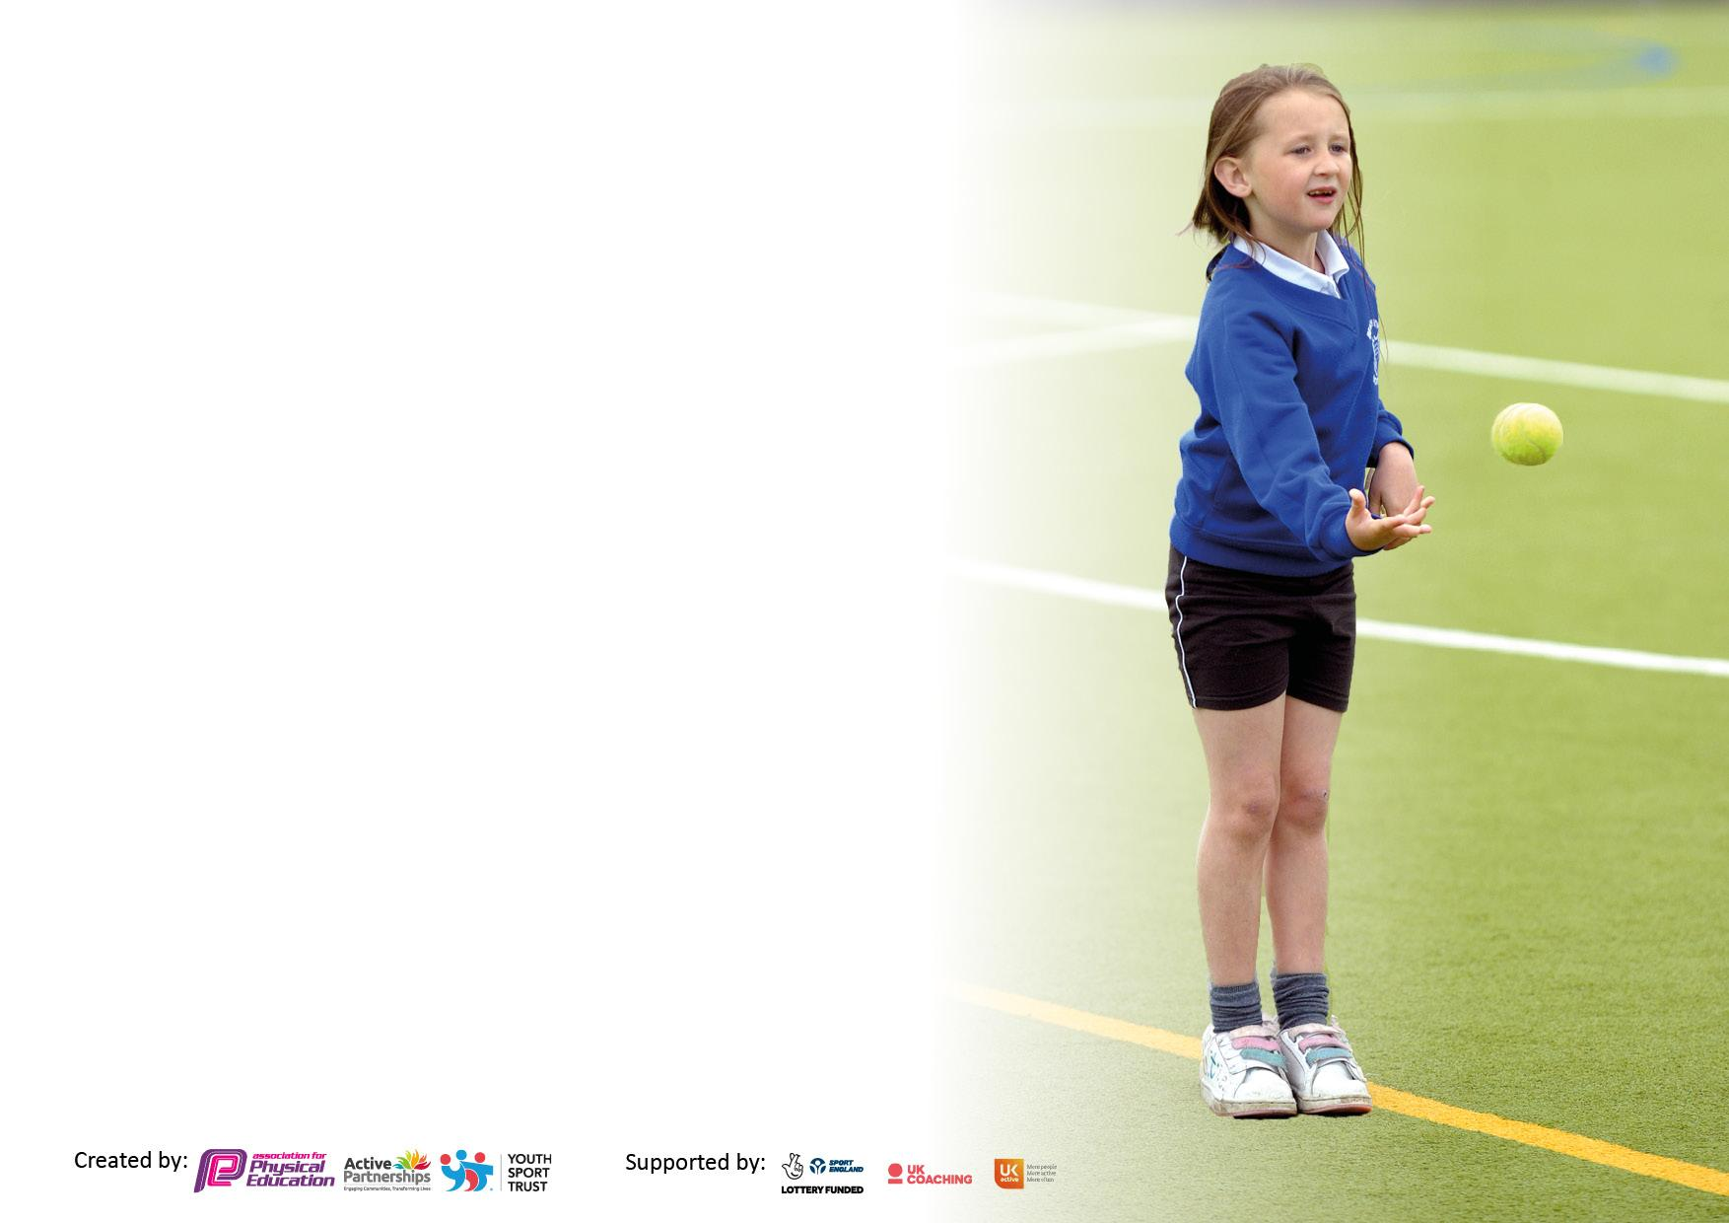

It is important that your grant is used effectively and based on school need. The Education Inspection Framework makes clear there will be a focus on ‘whether leaders and those responsible for governors all understand their respective roles and perform these in a way that enhances the effectiveness of the school’.

Under the Quality of Education Ofsted inspectors consider:
Intent - Curriculum design, coverage and appropriateness
Implementation - Curriculum delivery, Teaching (pedagogy) and Assessment
Impact - Attainment and progress

To assist schools with common transferable language this template has been developed to utilise the same three headings which should make your plans easily transferable between working documents.

Schools must use the funding to make additional and sustainable improvements to the quality of Physical Education, School Sport and Physical Activity (PESSPA) they offer. This means that you should use the Primary PE and sport premium to:

- Develop or add to the PESSPA activities that your school already offer
- Build capacity and capability within the school to ensure that improvements made now will benefit pupils joining the school in future years
- The Primary PE and sport premium should not be used to fund capital spend projects; the school’s budget should fund these.

Please visit gov.uk for the revised DfE guidance including the 5 key indicators across which schools should demonstrate an improvement. This document will help you to review your provision and to report your spend. DfE encourages schools to use this template as an effective way of meeting the reporting requirements of the Primary PE and sport premium.

We recommend you start by reflecting on the impact of current provision and reviewing the previous spend.

Schools are required to publish details of how they spend this funding, including any under-spend from 2019 2020, as well as on the impact it has on pupils’ PE and sport participation and attainment. All funding must be spent by 31st July 2022.

We recommend regularly updating the table and publishing it on your website throughout the year. This evidences your ongoing self-evaluation of how you are using the funding to secure maximum, sustainable impact. Final copy must be posted on your website by the end of the academic year and no later than the 31st July 2021. To see an example of how to complete the table please click HERE.

Details with regard to funding
Please complete the table below.

Total amount carried over from 2019/20 | £9397
Total amount allocated for 2020/21 | £20,050
How much (if any) do you intend to carry over from this total fund into 2021/22? | £0
Total amount allocated for 2021/22 | £19,980 (tbc)
Total amount of funding for 2021/22. To be spent and reported on by 31st July 2022. | £19,980 (tbc)

Swimming Data
Please report on your Swimming Data below.

Meeting national curriculum requirements for swimming and water safety.

N.B. Complete this section to your best ability. For example you might have practised safe self-rescue techniques on dry land which you can then transfer to the pool when school swimming restarts.
Due to exceptional circumstances priority should be given to ensuring that pupils can perform safe self rescue even if they do not fully meet the first two requirements of the NC programme of study
What percentage of your current Year 6 cohort swim competently, confidently and proficiently over a distance of at least 25 metres?  N.B. Even though your pupils may swim in another year please report on their attainment on leaving primary school at the end of the summer term 2020.  Please see note above | 80%
What percentage of your current Year 6 cohort use a range of strokes effectively [for example, front crawl, backstroke and breaststroke]?  Please see note above | 56%
What percentage of your current Year 6 cohort perform safe self-rescue in different water-based situations? | 62%
Schools can choose to use the Primary PE and sport premium to provide additional provision for swimming but this must be for activity over and above the national curriculum requirements. Have you used it in this way? | Yes/No

Action Plan and Budget Tracking
Capture your intended annual spend against the 5 key indicators. Clarify the success criteria and evidence of impact that you intend to measure to evaluate for pupils today and for the future.

Academic Year: 2020/21 | Total fund allocated: | Date Updated:
Key indicator 1: The engagement of all pupils in regular physical activity – Chief Medical Officers guidelines recommend that primary school pupils undertake at least 30 minutes of physical activity a day in school |  |  |  | Percentage of total allocation:
 |  |  |  | %
Intent | Implementation |  | Impact
Your school focus should be clear what you want the pupils to know and be able to do and about  what they need to learn and to  consolidate through practice: | Make sure your actions to achieve are linked to your intentions: | Funding allocated: | Evidence of impact: what do pupils now know and what can they now do? What has changed?: | Sustainability and suggested next steps:
Teachers plan and teach engaging PE lessons  Lunchtime organisers and TAs promote purposeful physical play activities at breaks and lunchtimes.  Extracurricular opportunities available to all children | Teachers given support when necessary following monitoring, evaluation and feedback from PE lead.  3 x weekly lessons  Promotion of physical activity at break times  Additional staff on playgrounds  Premier Education Coach to Provide training for Lunchtime organisers and TAs around purposeful physical play activities at breaks and lunchtimes.  Lunchtime clubs (Premier Ed)  After school clubs (Premier Ed)  daily mile  Provide and replenish suitable resources.  - Lunchtime club to provide opportunities for children within a heavier weight band to participate in regular, weekly exercise. Due to National figures stating that 25% of reception children and 40% of Yr 5/6 children are overweight. | £639 ( 3 days Nic Wilson salary)  £12,300 30 TA hrs pw for the year.  Inc below  £5,225  £ 2500  £1000  inc above
Key indicator 2: The profile of PESSPA being raised across the school as a tool for whole school improvement |  |  |  | Percentage of total allocation:
 |  |  |  | %
Intent | Implementation |  | Impact
Your school focus should be clear what you want the pupils to know and be able to do and about  what they need to learn and to  consolidate through practice: | Make sure your actions to achieve are linked to your intentions: | Funding allocated: | Evidence of impact: what do pupils now know and what can they now do? What has changed?: | Sustainability and suggested next steps:
To achieve the Silver School Games award  Increase participation in competition.  All Year 6 pupils have the best chance of learning to swim 25 m  All classes to have access to a 6 week extra curricular club.  Teaching staff recognise the imapce that physical activity has on mental and physical health and wellbeing. | Apply when available in 2022  (see 5 below)  Additional swimming for 9 y 6 pupils.  Plus 5 new pupils from Feb  Employ a sports coach  FT teaching staff to offer 6 week block of clubs  Whole staff training  Whole school Health  and Fitness week  Curriculum lead to develop website page to include photos of Sports Events and class and after school/lunchtime provision. | £  £623 cost per pupil x9?  £346  Inc above  £500  £2000

Key indicator 3: Increased confidence, knowledge and skills of all staff in teaching PE and sport |  |  |  | Percentage of total allocation:
 |  |  |  | %
Intent | Implementation |  | Impact
Your school focus should be clear | Make sure your actions to | Funding | Evidence of impact: what do | Sustainability and suggested
what you want the pupils to know | achieve are linked to your | allocated: | pupils now know and what | next steps:
and be able to do and about | intentions: |  | can they now do? What has
what they need to learn and to |  |  | changed?:
consolidate through practice:
Staff using PE passport confidently  PE lead to be up to date with local and national position.  Colleagues to feel confident in the curriculum delivery of dance and gym. | - Subject lead to evaluate usage and to give individual coaching support to those colleagues who lack confidence.  - Subject leader to access subject leader network courses and disseminate information.  - Provide whole staff training/coaching on gymnastics.  - Ensure appropriate and adequate resources are available for whole class teaching.  - PE Deep Dive | Inc above  £500  £1000  £1000  £411 (1 day Mike Swift time 1 day Nic wilson time)
Key indicator 4: Broader experience of a range of sports and activities offered to all pupils |  |  |  | Percentage of total allocation:
Intent | Implementation |  | Impact
Your school focus should be clear | Make sure your actions to | Funding | Evidence of impact: what do | Sustainability and suggested
what you want the pupils to know | achieve are linked to your | allocated: | pupils now know and what | next steps:
and be able to do and about | intentions: |  | can they now do? What has
what they need to learn and to |  |  | changed?:
consolidate through practice:

Increased awareness/ participation in a range of sports | - Competition entry for a wide range of sports.  - Martial arts for target Y5/6 boys group.  - Health and fitness week to offer a range of ‘new’ sports/activities. | (incl above)

Key indicator 5: Increased participation in competitive sport |  |  |  | Percentage of total allocation:
 |  |  |  | %
Intent | Implementation |  | Impact
Your school focus should be clear | Make sure your actions to | Funding | Evidence of impact: what do | Sustainability and suggested
what you want the pupils to know | achieve are linked to your | allocated: | pupils now know and what | next steps:
and be able to do and about | intentions: |  | can they now do? What has
what they need to learn and to |  |  | changed?:
consolidate through practice:
Access wider range of competitions for children across school | - Join Manchester PE Association and identify competitions to enter.  - Provide lunchtime clubs to prepare children for competitions  - Access any competitions/fun days offered in the community eg MUFC/MCFC fun days  - Transport to competitions  - Staffing to support competitions | £950  £ inc above  £ 1000  £415 days TA3 approx | Autumn Term:  Y5/6 Inspire Tag Rugby  Y5/6 Excel Tag Rugby  Y5/6 Boys Inspire football league  Y5/6 Boys Excel football league  Y5/6 Girls’ football league  Y3/4 mixed football festival x 2  Spring Term:  Dodgeball  Basket ball  Swim gala?  Hi 5 Netball

Signed off by
Head Teacher:
Date:
Subject Leader:
Date:
Governor:
Date:

