Baguley Hall Primary School

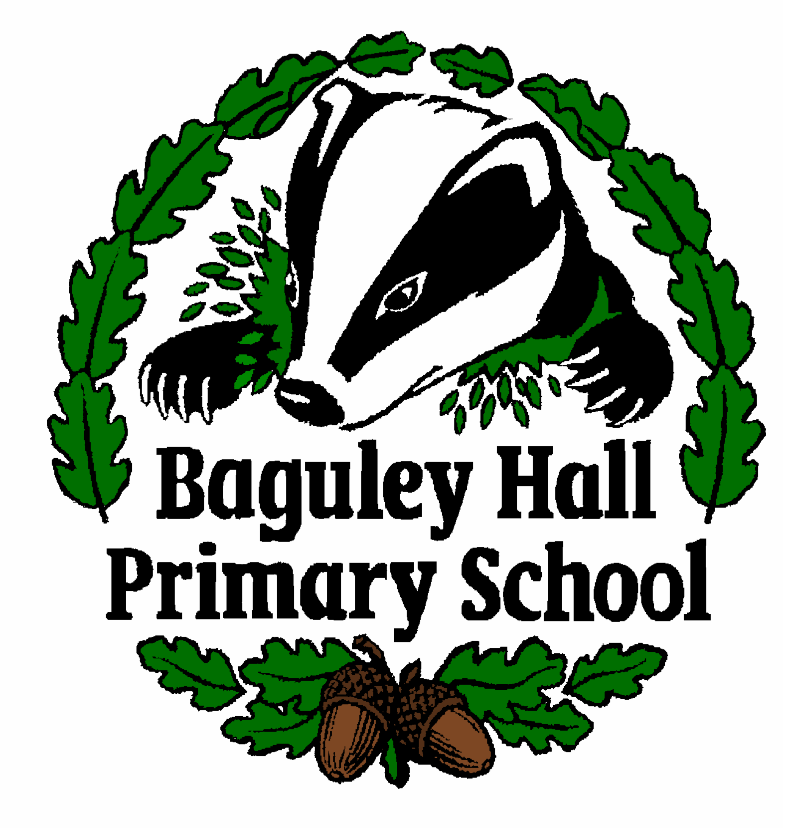

Dinner Money Policy

Date of Policy approval 31.10.2023____________
Date of Policy review __September 2024_________________
Signed _______ _____________________________________ (Chair of Governors)
Signed _______ _______________________________ (Chair of Resources Committee)

Dinner Money Policy

Baguley Hall Primary School
Ackworth Drive
Wythenshawe
Manchester
M23 1LB

Our school meals are prepared daily on site by our own in house catering team.

The meals provide a balanced, healthy diet and are good value for money. There is always a good choice of meals including a range of hot options, a selection of sandwiches and a salad bar. Refreshments are also included. Alternatively, children may bring a packed lunch or go home.

During lunchtime children are supervised by Lunchtime Organisers. In addition, the Headteacher and Senior Leadership Team are always available if necessary.

Free School Meals

Children at Foundation and key stages 1 and 2 qualify for free school meals if their parents or guardians are in receipt of any of the following benefits:

• Income Support
• Income-based Jobseekers Allowance
• Income-related Employment and Support Allowance
• Support under Part VI of the Immigration and Asylum Act 1999
• the guaranteed element of Pension Credit
• Child Tax Credit (where Working Tax Credit is not also received and the family’s annual gross income does not exceed £16,190)
• Working Tax Credit run-on - paid for 4 weeks after you stop qualifying for Working
Tax Credit
• Universal Credit (where the family’s annual after-tax income, excluding any benefits, is less than £7,400)

If your child qualifies for free school meals, you can apply for them via the link below:

https://secure.manchester.gov.uk/info/500186/education_benefits/7355/free_school_meals

Until the benefits department accepts your application please provide the School office with one of the following documents to confirm eligibility:

Income Support
Income-based Jobseeker’s Allowance
Income-related Employment Support Allowance
Pension Credit
Child Tax Credit

If your child is eligible for free school meals, they will remain eligible until they finish the phase of schooling (primary or secondary) they are in on 31 March 2022.

Entitlement to free school meals is not only beneficial to you and your child but it also has a positive impact on the funding received by the school.

Universal Infant Free School Meals

Pupils in Year1, Year 2 and Reception classes who are not otherwise entitled to free school meals are offered a free meal under the Government’s Universal Infant Free School Meal Scheme.

Ordering school meals and dietary requirements

- School meals are ordered in advance for the term ahead. At the end of each term we send home with your child the next term’s menus and a meal choice form for completion.
- Please take time to help your child to complete their meal choice form and return it to the school office to ensure that your child receives their preferred meal choices.
- Please also use the form to tell us if your child has any dietary requirements. It is important that we know this as soon as possible so we can have everything in place for the start of the new term.
- If your child wishes to change their meal arrangement please ask the school office for a meal change form and return it completed to the office at least one whole week before you wish the change to take effect. This period is needed as kitchen orders are processed in advance.
- Should a child who has packed lunches, forget their meal or require a lunch due to exceptional circumstances a school meal will be provided. This meal must be paid for unless the child is entitled to free school meals. For children not entitled to free school meals the cost of a meal is currently £2.25.

Paid School Meals

Dinner money is currently £11.25 per week. Payments are made via the school’s online payment system, School Spider

Meals eaten during a week must be paid for, at the latest, by the Friday of that week. If meals are not paid for this is classed as dinner money arrears.

Dinner money arrears are not allowed. If a pupil has dinner money arrears of 10 meals the school may ask the parent to provide packed lunches until the arrears are paid.

The escalation process for the collection of dinner money arrears is as follows:

- Dinner money arrears of 5 meals – ACTION: Reminder text to parent.

- Dinner money arrears of 10 meals – ACTION: Telephone call to parent advising that packed lunches must be provided until the arrears are paid.

We will make every effort to support families who are experiencing difficulties in paying arrears, working with them to secure a positive outcome in the interest of their children.

However, where dinner money arrears remain unresolved we reserve the right to refer the matter to Manchester City Council Legal Department for debt recovery.

