Guided reading overview of texts

 |  | Autumn Term  (swap over) |  | Spring Term  (swap over) |  | Summer Term  (swap over)
Year 2 |  |  |  |  | The Day the Crayons Quit  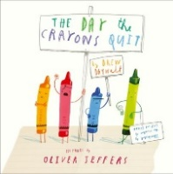 | Traction Man is here  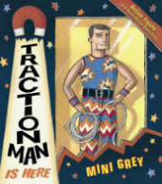 | Grandpa Bert and the Ghost snatchers  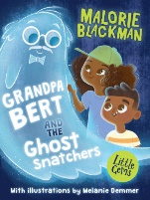
Year 3 |  | Dread Cat  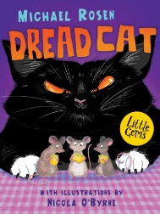 | George’s Marvellous Medicine – Roald Dahl  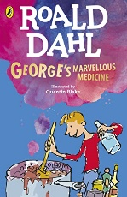 | The Cat and the king by Nick Sharratt  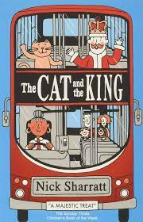 | Sam Wu is not afraid of sharks – Katie and Kevin Tsang  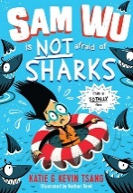 | Egyptian Cinderella – Shirley Climo  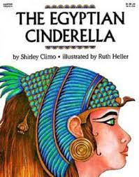 | The Ice Palace.  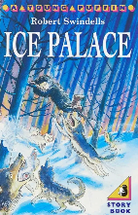
Y3/4 split class |  | As above | As above | The Diary of a Killer Cat | The very best of Paul Cookson | The White Fox | Ancient Egyptian gods and goddesses
Year 4 |  | Fortunately the milk – Neil Gaiman  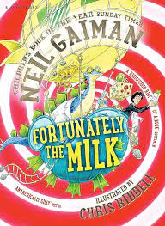 | The Hodgeheg – Dick King Smith  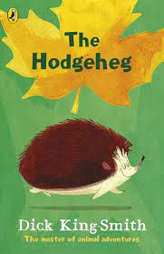 | The Iron Man – Ted Hughes  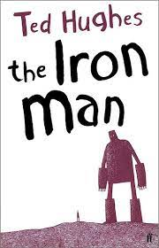 | The Butterfly Lion – Michael Morpurgo  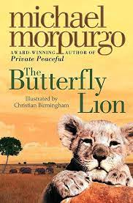 | Akimbo and the lions – Alexander McCall  Smith  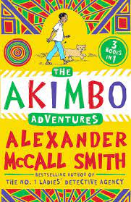 | The Firework Maker’s Daughters – Phillip Pullman  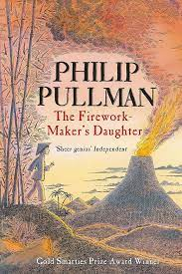
Year 5 |  | Autumn 1 | Autumn 2 | Spring 1 | Spring 2 | Summer 1 | Summer 2
 |  | The Wild Robot – Peter Brown  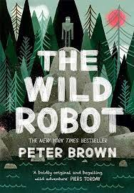 | Who let the Gods out? Maz Evans  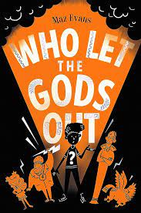 | Beetle Boy – M.G Leonard  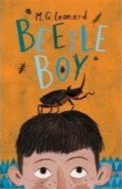  The House with Chicken Legs  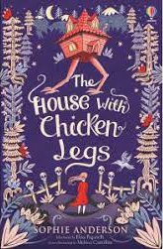 | The astounding broccoli boy – Frank Cotterell Boyce  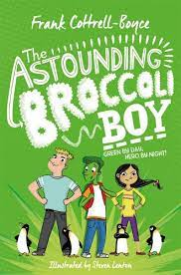 | Tamarind and the star of Ishtar  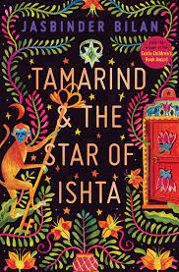  Brightstorm – Vashti Hardy  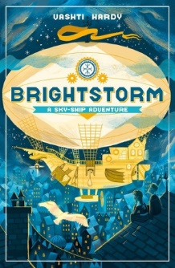 | Clockwork – Phillip Pullman  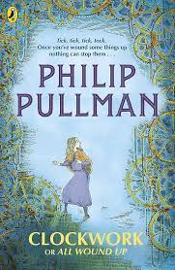
UKS2 Fresh Start Group (2 year cycle) |  | Fantastic Fables  Cliffhanger  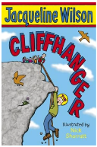 | Hercules  Stone age Boy/Viking Vik and the Wolves | The Victorians  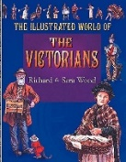  The White Fox | Fair’s Fair  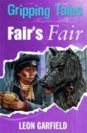  Benjamin Blog America | Grandpa Bert and the Ghost Snatchers  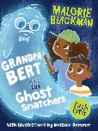  Diary of a Killer Cat | Dread Cat  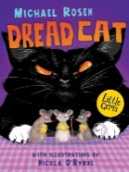  The Twits  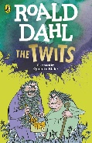
Year 6 |  | Percy Jackson And The Lightning Thief  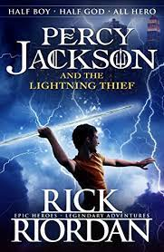 | The Explorer – Katherine Rundell  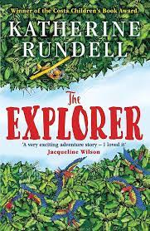 | The nowhere emporium – Ross MacKenzie  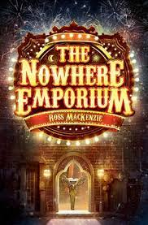 | Letters from the Lighthouse by Emma Carroll  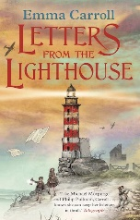 | Holes  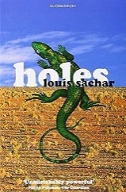 | Holes

